**Sean Conway T00196102**

**Question 2**

In a typical 3D game, graphical models are created and animated on a package similar to 3D Studio Max. Typically, there would be a large amount of data needed to define the model, which would also have to be processed each frame.

1. Derive a vertex and index lists for a cube. Please ensure that you state and comply with any conventions for the definition of the vertices and the faces. (10 Marks)

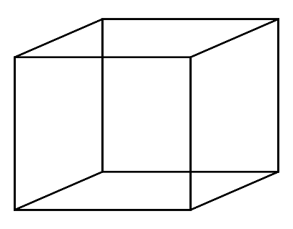

The origin is in the centre of the object.

All vertices are named counter-clockwise

Vertex List

|  |  |  |  |
| --- | --- | --- | --- |
|  | X | Y | Z |
| 0 | -1 | -1 | 1 |
| 1 | -1 | 1 | 1 |
| 2 | -1 | -1 | -1 |
| 3 | -1 | -1 | 1 |
| 4 | 1 | -1 | 1 |
| 5 | 1 | -1 | -1 |
| 6 | 1 | 1 | 1 |
| 7 | 1 | 1 | -1 |

Index List

|  |  |  |  |  |  |
| --- | --- | --- | --- | --- | --- |
| 0 | 0 | 2 | 5 | 7 | Front |
| 1 | 1 | 3 | 4 | 6 | Back |
| 2 | 0 | 1 | 6 | 7 | Top |
| 3 | 2 | 3 | 4 | 5 | Bottom |
| 4 | 1 | 0 | 3 | 2 | Left |
| 5 | 7 | 6 | 4 | 5 | Right |

1. The use of vertex and index lists saves memory. Why and how much? (4 Marks)

Index buffers are used to save memory by listing indices into the vertex buffer, rather than giving an explicit vertex buffer to the renderer.

(c) The model above is to be textured as a die, o which opposite sides always add to 7. If the texture for this was as below...

(i) Describe in words what this will do to the model (1 Mark)

It will end up in the form of a cube.

(ii) Derive the data required for the mesh to do this. (10 Marks)

|  |  |  |  |  |  |
| --- | --- | --- | --- | --- | --- |
| 0 | 0 | 2 | 5 | 7 | Front |
| 1 | 1 | 3 | 4 | 6 | Back |
| 2 | 0 | 1 | 6 | 7 | Top |
| 3 | 2 | 3 | 4 | 5 | Bottom |
| 4 | 1 | 0 | 3 | 2 | Left |
| 5 | 7 | 6 | 4 | 5 | Right |

|  |  |  |  |  |  |
| --- | --- | --- | --- | --- | --- |
| 0 | 1 | 3 | 4 | 6 | Front |
| 1 | 0 | 2 | 5 | 7 | Back |
| 2 | 0 | 1 | 6 | 7 | Top |
| 3 | 2 | 3 | 4 | 5 | Bottom |
| 4 | 0 | 1 | 3 | 2 | Left |
| 5 | 7 | 6 | 4 | 5 | Right |